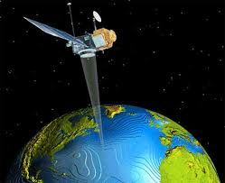
Benha University
Faculty of Engineering _Shoubra
Surveying Engineering Department
Fourth Year
Year: 2017/2018
Semester: One
Remote Sensing and Photo Interpretation
Assignment No: 4

Image Classification
- What is Image Classification?
- Methods of Classification used in GIS Analysis.
- Define the following terms:
- Spectral Signature.
- Signature Evaluation.
- Minimum Distance Classifier.
- Maximum Likelihood.
- Region Grow AOI.
- Euclidian Distance.
- Advantage and Disadvantage of Supervised and Unsupervised Classification.
- Determine areas of continuous spectral response at pixel 5 by region grow AOI, if the Euclidian Distance = (0,1,1,2,3) and Neighborhood = (4,4,8,8,8) respectively.
10 | 10 | 10 | 6 | 5 | 4
9 | 8 | 8 | 7 | 6 | 5
10 | 10 | 4 | 5 | 7 | 10
11 | 10 | 4 | 4 | 8 | 9
10 | 8 | 7 | 6 | 10 | 10
11 | 3 | 9 | 7 | 10 | 11

- List the different criteria according to which the USGS Classification System was designed.
- Write in detail about the following:
- Parallelepiped Decision Rule.
- Accuracy Assessment of Classification.

